OS Lab Project

Phase 1:
Task 1 — Installation
- Install VMware or virtual Box
- Download and use the Ubuntu or windows 10/11 ISO file.
- Complete the installation of Ubuntu OS or windows 10/11 ISO file in
VMware or virtual Box.
- DONE....
Task 2 — Configure Virtual Machines
- Create the first virtual machine and install Ubuntu (Ubuntu 1).
- Create another virtual machine inside VMware, so that you have two
Ubuntu operating systems within the same VMware environment.
- DONE.....
Task 3 — Network Configuration
- Configure the network settings so that Ubuntu OS or windows 10/11 ISO
file 1 and Ubuntu OS 2 can communicate with each other.
- Test the connection by using the ping command from OS1 to OS2.

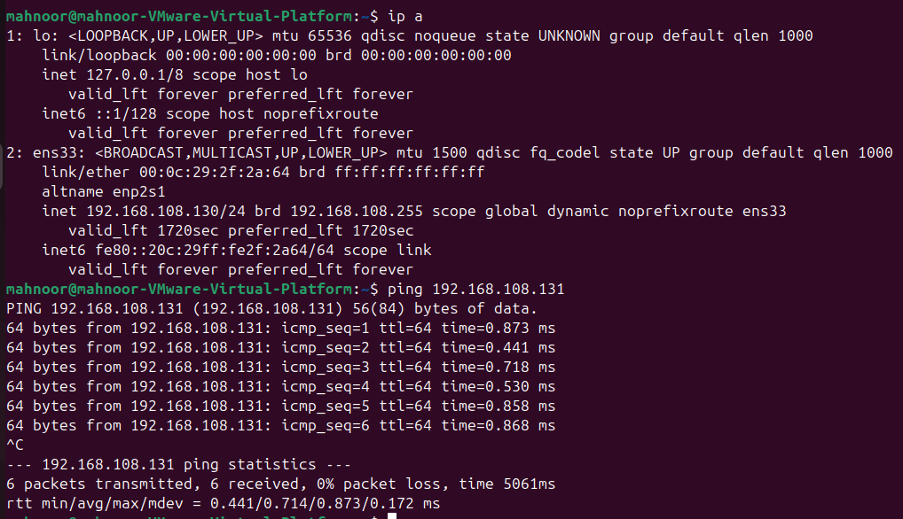
- Pinging Ubuntu 2.

- Pinging Ubuntu 1.
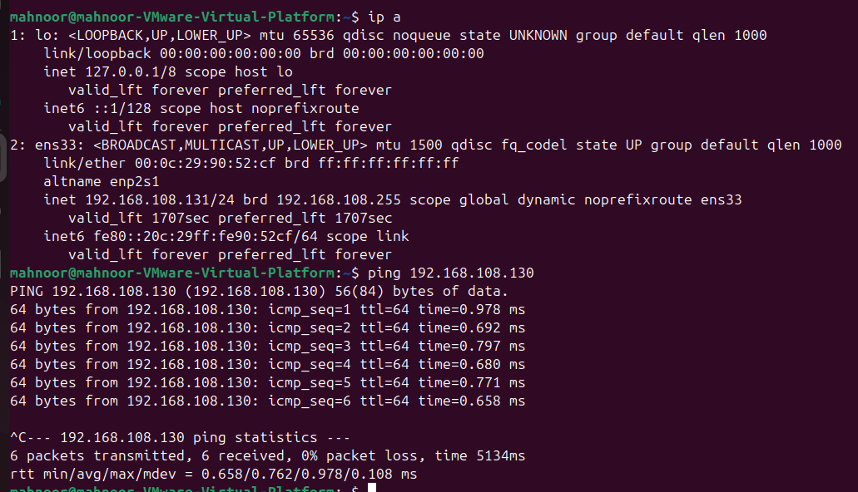
- DONE......

_____________________________________________

